Daniel Piston

IST 659

IST 659 Database project report

Onward to Opportunity Database

Contents

Summary 2

Stakeholders 2

Business Rules 2

Glossary 3

Data Questions 3

Conceptual Model 5

Logical Model 6

Physical Database Design 7

User Interface 20

Database Updates 21

Sample Reporting 21

Reflection 24

Final Summary 25

## Summary

The focus for this project will be to design and create a database for a department of Syracuse University called the Institute for Veterans and Military Families (IVMF). The IVMF is a research institute, but also provides the military connection community with programs designed to aid in providing education and training courses on entrepreneurship and career transition. The main program for career transition is called the Onward to Opportunity program (O2O). This program provides military connected individuals the opportunity to prepare for an industry recognized certification and the coursework required to prepare the individual. The data source for this project will be a SQL server database that stores the tables from Salesforce.

## Stakeholders

The stakeholders for this project are primarily focused on the business intelligence team (reporting) and the program leadership that consume on a regular basis in a detailed manner to support business decisions and reporting to external stakeholders. Additional internal stakeholders include organization leadership and the development (fundraising) team, which typically focus on high level data and interesting insights to gain attention. Implementing the database will be used to increase efficiency while also aiding in data cleaning to ease of the reporting burden. A goal of the BI team is also to increase the building and use of visualizations and dashboards, which the database will enhance.

## Business Rules

1. A contact is only created if they completed an application to be considered for the program.
2. Once a contact has completed an application, an assessment is automatically triggered to complete.
3. Each program enrollment has a corresponding application.
4. A participant is considered enrolled if they utilize a license to start their coursework.
5. Each participant is assigned a cohort if enrolled.
6. Each participant may enroll in multiple courses within a single program instance or cohort.
7. A participant can re-enroll if they never used a license to begin their coursework.
8. Each participant is assigned a single advisor throughout their course.

## Glossary

1. Participant: Anyone that applies to become enrolled in the program or enrolls in the program.
2. Application: The initial form that is completed to be considered for the program.
3. Enrollment: A record for each course a participant starts in the program.
4. Cohort: The class that a participant is part of. Typically annotated by location and time period that they started the program.
5. Program Instance: A unique number that denotes which cohort a participant enrolled in. Also denotes a table that contains all information on the specific cohort.
6. License: Refers to a Skillsoft or other LMS license that provides an online platform for certification coursework.

## Data Questions

1. How many participants have enrolled in the program during a specific period or all time?
2. How many participants have enrolled based on location?
3. How many participants have achieved a positive outcome (completed coursework, was hired etc.) during a specific period or all time?
4. What is the rate of completion for program participants?
5. Where are the program graduates currently located?
6. What are the demographic data for the participants that have enrolled?
7. Where companies do program graduates work for?
8. What predicts a positive outcome for a currently enrolled participant?
9. How many courses has one a participant taken in the program?

## Conceptual Model

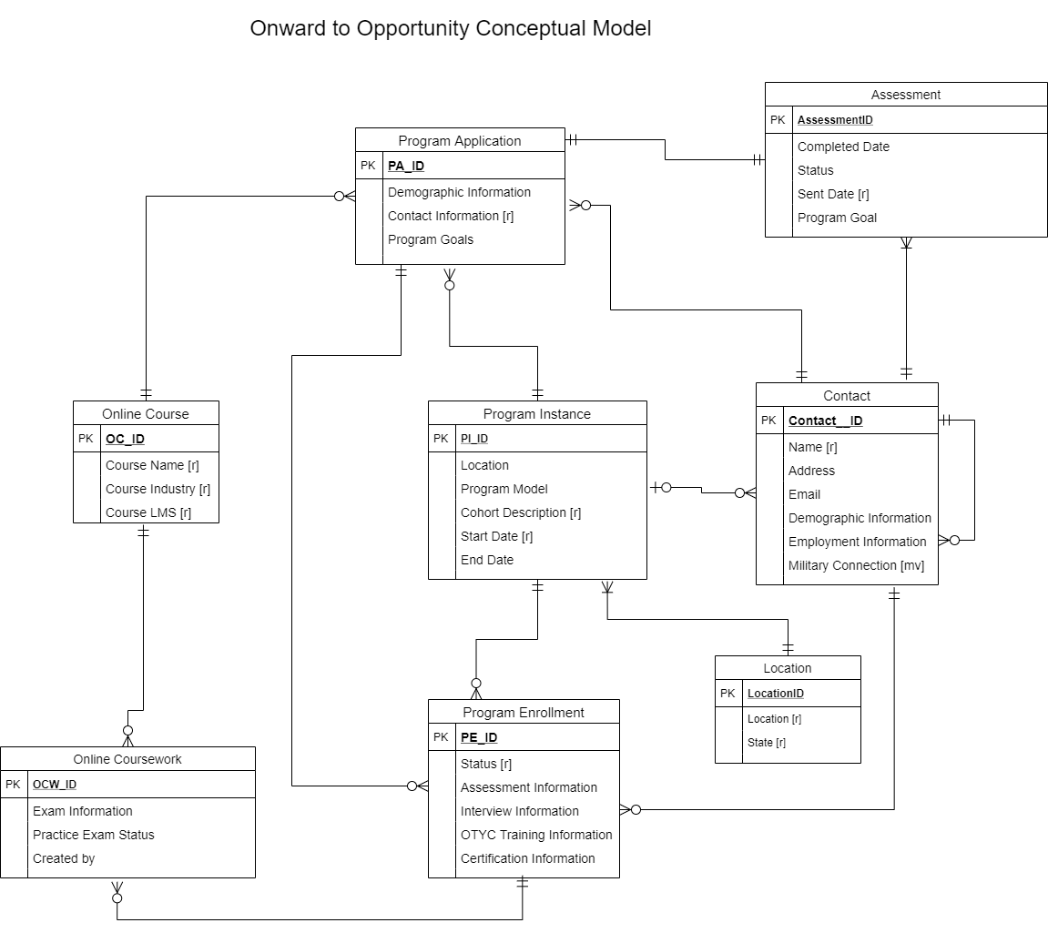

## Logical Model

## Physical Database Design

The database design below was create using Microsoft SQL Server Management Studio. The data that was inserted into the created tables below came from another server. We used our current user SAS interface with the first database to act as bridge in which to rename and clean some of the data, and create new tables. The data was then inserted from SAS using SAS SQL syntax, into the tables created in Microsoft SQL Server Studio.

Steps to create database:

1. Create fresh table in new database with correct names and lengths
2. Extract specific columns from current back up database into SAS
3. Rename, clean and create new tables as needed in “Transfer” tables
4. Insert cleaned and renamed data into new database from SAS

--O2O Database table creation

--Created all tables in SQL

--Created transfer tables in SAS in which variables were renamed from data pulled from Salesforce database

--Inserted from SAS transfer tables into created SQL tables

--Each table has corresponding insert SAS syntax

--Table 1: Locations

--Create Locations table template for Location data

create table Locations

(

Location_ID varchar(18) not null

,Location_Name varchar(60)

,Location_State varchar(20)

,Location_Last_Modified_Date datetime not null

,constraint Locations_PK primary key (Location_ID)

)

select * from Locations

/*

--Transfer table to rename variables and clean

proc sql;

create table Locations_Transfers as

select

ID as Location_ID

,Namex as Location_Name

,statex as Location_State

,lastmodifieddate as Location_Last_Modified_Date

from DBSFPRD.sf_location

; quit;

--Location insert syntax in SAS

proc sql;

insert into DBO2OTST.Locations

select *

from Locations_Transfers

; quit;

*/

--------------------------------------------------------------------------

--Table 2: Online_Courses

--Create Online_Courses table template for OC data

create table Online_Courses

(

Online_Course_ID char(18) not null

,OC_Condensed_Industry varchar(50)

,OC_Industry varchar(50)

,OC_LMS varchar(30) not null

,OC_Online_Course varchar(80) not null

,OC_Current_Status char(5) not null

,constraint Online_Courses_PK primary key (Online_Course_ID)

)

select * from Online_Courses

/* Online course transfer table creation in SAS to clean and change variable names

proc sql;

create table Online_Courses_Transfer as

select

ID as Online_Course_ID

,Condensed_industry as OC_Condensed_Industry

,industry as OC_Industry

,LMS as OC_LMS

,namex as OC_Online_Course

,currentx as OC_Current_Status

from dbsfprd.sf_online_course

;quit;*/

--Online_Courses insert SAS syntax

/*

proc sql;

insert into DBO2OTST.Online_Courses

select *

from Online_Courses_Transfer

; quit;*/

---------------------------------------------------------------------------

--Contacts Look-Up Tables

drop table Branches

--Create Branches look up table

create table Branches

(

Branch_ID int primary key

, Branch varchar(20) not null

)

insert into Branches

values (1, 'Air Force')

,(2, 'Army')

,(3, 'Coast Guard')

,(4, 'Marine Corps')

,(5, 'Navy')

,(10, 'Air Force Reserve')

,(11, 'Army Reserve')

,(12, 'Coast Guard Reserve')

,(13, 'Marine Corps Reserve')

,(14, 'Navy Reserve')

,(20, 'Air National Guard')

,(21, 'Army National Guard')

,(22, 'National Guard')

select * from Branches

--Create Military_Connection ID table

create table Military_Connections

(

Military_Connection_ID int identity primary key

, Military_Connection varchar(40)

)

insert into Military_Connections

values ('Service Member')

,('Activated National Guard/Reserves')

,('Non-Activated National Guard/Reserves')

,('Spouse')

,('Veteran')

,('Undisclosed/Missing')

select * from Military_Connections

drop table Military_Connections

---------------------------------------------------------------------------

--Table 3: Contacts

create table Contacts

(

Contact_ID char(18)

,Contact_Created_Date datetime not null

,Contact_Source varchar(150)

,Contact_First_Name varchar(50) not null

,Contact_Last_Name varchar(100)not null

,Contact_Email varchar(100)

,Contact_Phone varchar(50)

,Contact_Home_Phone varchar(50)

,Contact_Cell_Phone varchar(50)

,Contact_Ethnicity varchar(50)

,Contact_Gender varchar(30)

,Contact_Level_of_Ed varchar(75)

,Contact_Active_Duty_Status varchar(75)

,Contact_Active_Duty varchar(5)

,Contact_Birthdate datetime

,Contact_Rank char(25)

,Contact_Terminal_Leave_Date datetime

,Contact_First_Interview datetime

,Contact_Date_of_Seperation datetime

,Contact_Do_Not_Mail char(5)

,Contact_Duty_Station varchar(250)

,Contact_Mailing_State varchar(60)

,Contact_Zip char(20)

,Contact_Marital_Status varchar(25)

,Contact_Military_Specialty varchar(300)

,Contact_Employment_status varchar(200)

,Contact_Employer varchar(150)

,Contact_Position varchar(150)

,Contact_Employer_Instituion varchar(200)

,Contact_Employer_Partner varchar(50)

,Contact_Emp_Start_Date datetime

,Contact_Employment_Location varchar(200)

,Contact_IVMF_Start_Date datetime

,Contact_Employment_Zip char(12)

,Contact_Employment_Notes varchar(1500)

,Contact_Outcome_Type varchar(10)

,Contact_Placed_By varchar(5)

,Contact_Employment_Position varchar(150)

,Contact_IVMF_Salary_Range varchar(20)

,Contact_Type_of_Degree varchar(75)

,Contact_Confirmed_Hire_Date datetime

,Contact_Hired_Location varchar(150)

,Contact_Hired_Emp_Part char(5)

,Contact_Discharge_Status varchar(60)

,Contact_Salary_Range varchar(20)

,Contact_Matched_Emp_Part varchar(90)

,HHUSA_Employ_Start_Date varchar(30)

,HHUSA_Color_Status char(10)

,HHUSA_Status_Notes varchar(200)

,Contact_Hired_Zip char(10)

,Contact_Emp_Outcome_Type char(20)

,Contact_HHUSA_Opt_Out varchar(60)

,Contact_Sent_to_HHUSA datetime

,constraint Contacts_PK primary key (Contact_ID)

)

select * from contacts

/* Transfer table syntax to rename columns and clean if needed

proc sql ;

create table Contacts_Transfer as

select

ID as Contact_ID

,createddate as Contact_Created_Date

,contactsource as Contact_Source

,firstname as Contact_First_Name

,lastname as Contact_Last_Name

,email as Contact_Email

,phone as Contact_Phone

,homephone as Contact_Home_Phone

,mobilephone as Contact_Cell_Phone

,ethnicity as Contact_Ethnicity

,gender as Contact_Gender

,level_of_education as Contact_Level_of_Ed

,active_duty_status as Contact_Active_Duty_Status

,active_duty as Contact_Active_Duty

,birthdate as Contact_Birthdate

,rank_at_separation as Contact_Rank

,terminal_leave_date as Contact_Terminal_Leave_Date

,date_of_first_interview as Contact_First_Interview

,date_of_separation as Contact_Date_of_Seperation

,DO_NOT_MAIL as Contact_Do_Not_Mail

,duty_station as Contact_Duty_Station

,mailingstate as Contact_Mailing_State

,mailingpostalcode as Contact_Zip

,marital_status as Contact_Marital_Status

,military_specialty as Contact_Military_Specialty

/*Unsure where these come from*/

,Employment_status as Contact_Employment_Status

,Employer as Contact_Employer

,positionx as Contact_Position

/*IVMF fields*/

,EMPLOYER_INSTITUTION as Contact_Employer_Instituion

,EMPLOYER_PARTNER as Contact_Employer_Partner

,EMPLOYMENT_START_DATE as Contact_Emp_Start_Date

,EMPLOYMENT_LOCATION as Contact_Employment_Location

,IVMF_HIRED_START_DATE as Contact_IVMF_Start_Date

,EMPLOYMENT_ZIP_CODE as Contact_Employment_Zip

,EMPLOYMENT_NOTES as Contact_Employment_Notes

,OUTCOME_TYPE as Contact_Outcome_Type

,PLACED_BY as Contact_Placed_By

,EMPLOYMENT_POSITION as Contact_Employment_Position

,EMPLOYMENT_SALARY_RANGE as Contact_IVMF_Salary_Range

,TYPE_OF_DEGREE as Contact_Type_of_Degree

/*HHUSA Fields*/

,CONFIRMED_HIRE_DATE as Contact_Confirmed_Hire_Date

,HIRED_LOCATION as Contact_Hired_Location

,HIRED_BY_PARTNER_EMPLOYER as Contact_Hired_Emp_Part

,DISCHARGE_STATUS as Contact_Discharge_Status

,SALARY_RANGE as Contact_Salary_Range

,MATCHED_PARTNER_EMPLOYER as Contact_Matched_Emp_Part

,HHUSA_EMPLOYMENT_START_DATE as HHUSA_Emp_Start_Date

,HHUSA_COLOR_STATUS as HHUSA_Color_Status

,HIRE_MATCH_STATUS_NOTES as Contact_Status_Notes

,HIRED_ZIP_CODE as Contact_Hired_Zip

,employment_outcome_type as Contact_Emp_Outcome_Type

,hhusa_opt_out as Contact_HHUSA_Opt_Out

,sent_to_hhusa as Contact_Sent_to_HHUSA

from dbsfprd.sf_contact

;

quit; */

/* Insert syntax

proc sql;

insert into DBO2OTST.Contacts c

select *

from Contacts_Transfer

where not exists (select Contact_ID from DBO2OTST.Contacts d where c.Contact_ID = d.Contact_ID)

; quit;*/

----------------------------------------------------------------------------

--Contacts Bridge tables to solve many to many relationship between contact table and branches table

create table Branches_Bridge

(

Branch_Bridge_ID int identity not null

,Contact_ID char(18) not null

,Branch_ID int not null

,constraint Branches_PK primary key (Branch_Bridge_ID)

,constraint Branches_Bridge_FK1 foreign key (Contact_ID) references Contacts

,constraint Branches_Bridge_FK2 foreign key (Branch_ID) references Branches

)

--Create Bridge Transfer table without any constraints to bring data in from SAS

create table Branches_Bridge_Transfer

(Contact_ID char(18) not null

,Branch_ID int not null)

select * from Branches_Bridge_Transfer

--Insert from Transfer table to allow for identity function to work properly

SET IDENTITY_INSERT dbo.Branches_Bridge ON;

insert into Branches_Bridge

(Contact_ID, Branch_ID)

select Contact_ID, Branch_ID

from Branches_Bridge_Transfer

SET IDENTITY_INSERT dbo.Branches_Bridge OFF;

select * from Branches_Bridge

/* Branches SAS syntax to clean and inset into Branches_Bridge_Transfer table

proc sql;

create table Contact_Branch_Transfer as

select

ID as Contact_ID

,BRANCH_OF_SERVICE as Contact_Branch

,strip(scan(BRANCH_OF_SERVICE,1,',;')) as Branch_1

,strip(scan(BRANCH_OF_SERVICE,2,',;')) as Branch_2

,strip(scan(BRANCH_OF_SERVICE,3,',;')) as Branch_3

,strip(scan(BRANCH_OF_SERVICE,4,',;')) as Branch_4

,strip(scan(BRANCH_OF_SERVICE,5,',;')) as Branch_5

from dbsfprd.sf_contact

where find(contactsource,'O2O','i') > 0 or find(contactsource,'vctp','i') > 0

order by Contact_ID

;

quit;

proc transpose data=Contact_Branch_Transfer out=Contact_Branch_Table (rename=(col1=Branch) drop=_Name_);

by Contact_ID;

var Branch_1 Branch_2 Branch_3 Branch_4 Branch_5;

run;

proc sql;

create table Branches_Bridge_Transfer as

select Contact_ID,

case Branch

when 'Air Force' then 1

when 'Army' then 2

when 'Coast Guard' then 3

when 'Marine Corps' then 4

when 'Navy' then 5

when 'Air Force Reserve' then 10

when 'Army Reserve' then 11

when 'Coast Guard Reserve' then 12

when 'Marine Corps Reserve' then 13

when 'Navy Reserve' then 14

when 'Air National Guard' then 20

when 'Army National Guard' then 21

when 'National Guard' then 22

else 99 end as Branch_ID

from (

select Contact_ID,

case Branch

when 'Marines' then 'Marine Corps'

else Branch end as Branch

from Contact_Branch_Table

where Branch ne '')

; quit;

*/

---------------------------------------------------------------------------------

--Create bridge table to solve many to many relationship between contact table and military connection table

create table Military_Connections_Bridge

(

MilConnect_Bridge_ID int identity not null

,Contact_ID char(18) not null

,Military_Connection_ID int not null

,constraint MilConnect_Bridge_PK primary key (MilConnect_Bridge_ID)

,constraint MilConnect_Bridge_FK1 foreign key (Contact_ID) references Contacts

,constraint MilConnect_Bridge_FK2 foreign key (Military_Connection_ID) references Military_Connections

)

--select * from Military_Connections_Bridge

--Create transfer table without constraints to transfer clean data from SAS

create table MilConnect_Bridge_Transfer

(Contact_ID char(18) not null

,Military_Connection_ID int not null)

--select * from MilConnect_Bridge_Transfer

--Insert data from transfer table into bridge table with contraints

SET IDENTITY_INSERT dbo.Military_Connections_Bridge ON;

insert into Military_Connections_Bridge

(Contact_ID, Military_Connection_ID)

select Contact_ID, Military_Connection_ID

from MilConnect_Bridge_Transfer

SET IDENTITY_INSERT dbo.Military_Connections_Bridge OFF;

/* SAS syntaxt to clean military connection data and insert into military connection bridge table

proc sql;

create table Contact_MilConnect_Transfer as

select

ID as Contact_ID

,military_connection as Contact_Military_Connection

,strip(scan(military_connection,1,',;/')) as Military_Connection_1

,strip(scan(military_connection,2,',;/')) as Military_Connection_2

,strip(scan(military_connection,3,',;/')) as Military_Connection_3

,strip(scan(military_connection,4,',;/')) as Military_Connection_4

,strip(scan(military_connection,5,',;/')) as Military_Connection_5

,strip(scan(military_connection,6,',;/')) as Military_Connection_6

,strip(scan(military_connection,7,',;/')) as Military_Connection_7

,strip(scan(military_connection,8,',;/')) as Military_Connection_8

,strip(scan(military_connection,9,',;/')) as Military_Connection_9

from dbsfprd.sf_contact

where find(contactsource,'O2O','i') > 0 or find(contactsource,'vctp','i') > 0

order by Contact_ID

;

quit;

proc transpose data=Contact_MilConnect_Transfer out=Military_Connection_Table (rename=(col1=Military_Connection) drop=_Name_);

by Contact_ID;

var Military_Connection_1 - Military_Connection_9;

where Contact_Military_Connection ne '';

run;

proc sql;

create table MilConnect_Bridge_Transfer as

select *

from (

select Contact_ID,

case Military_Connection

when 'Active Duty' then 1

when 'Active duty' then 1

when 'Servicemember' then 1

when 'Activated National Guard' then 2

when 'Activated NationalGuard' then 2

when 'Activated Reserve' then 2

when 'National Guard' then 3

when 'Reserves' then 3

when 'Military Spouse' then 3

when 'Partner' then 3

when 'Spouse' then 3

when 'Spouse of a service member' then 3

when 'on Spouse of a service member' then 3

when 'I am a retired' then 4

when 'Veteran' then 4

when 'veteran' then 4

when 'Retiree' then 4

when 'separated service member' then 4

when 'Unclear - BSF Referral' then 5

when 'None of the above' then 5

end as Military_Connection

from Military_Connection_Table

where Military_Connection ne '')

; quit;

proc sql;

insert into DBO2OTST.MilConnect_Bridge_Transfer

select *

from MilConnect_Bridge_Transfer

; quit;

*/

----------------------------------------------------------------------------

--Table 3: Program_Instances

create table Program_Instances

(

Program_Instance_ID char(18) not null

,PI_O2O_Model varchar(12)

,PI_Program char(12)

,PI_Program_Instance_desc varchar(60)

,PI_Number char(10)

,PI_Cohort_Name varchar(50)

,PI_Start_date datetime

,PI_End_Date datetime

,Location_ID char (18)

,constraint Program_Instance_PK primary key (Program_Instance_ID)

,constraint Program_Instance_FK1 foreign key (Location_ID) references Locations

)

select * from Program_Instances

/*

--Look-up Table 1: PI_Bridge

create table Program_Instances_Bridge

(

PI_Bridge_ID int identity

,Contact_ID char(18)

,Program_Instance_ID char(18)

,constraint PI_Bridge_PK primary key (PI_Bridge_ID)

,constraint PI_Bridge_FK1 foreign key (Contact_ID) references Contacts

,constraint PI_Bridge_FK2 foreign key (Program_Instance_ID) references Program_Instances

)

insert into Program_Instances_Bridge

values (

--select * from Program_Instances_Bridge

create table PI_Bridge_Transfer

( Contact_ID char(18)

,Program_Instance_ID char(18))

select * from PI_Bridge_Transfer

where Contact_ID is null

SET IDENTITY_INSERT dbo.Program_Instances_Bridge ON;

insert into Program_Instances_Bridge

(Contact_ID, Program_Instance_ID)

select Contact_ID, Program_Instance_ID

from PI_Bridge_Transfer

select * from Program_Instances_Bridge*/

---------------------------------------------------------------------------

--Table 4: Program_Applications

--Program Applications

create table Program_Applications

( Program_Application_ID char(18) primary key not null

,PA_Application_Date datetime

,PA_Created_Date datetime

,PA_Application_Number char (8)

,PA_Program_Name varchar(25)

,PA_Heard_About_Through varchar(100)

,PA_Online_Course_Preference varchar(100)

,PA_Program_Instance_Desc varchar(50)

,PA_Status varchar(50)

,PA_Program_Application_Origin varchar(50)

,PA_Program_Completion_Goal varchar(100)

,PA_Live_Within_50m varchar(60)

,PA_Cybervet_Geographic_Status varchar(40)

,PA_O2O_Career_Track varchar(30)

,PA_OTYC_Start_Date datetime

,PA_Orientation_Status char(8)

,PA_Discharge_Status char(21)

,PA_Assessment_Status char(23)

,PA_Assessment_Submitted_Date datetime

,PA_Withdraw_Reason varchar(33)

,Contact_ID char(18)

,Program_Instance_ID char(18)

,Online_Course_ID char(18)

,constraint Program_Applications_FK1 foreign key (Contact_ID) references Contacts

,constraint Program_Applications_FK2 foreign key (Program_Instance_ID) references Program_Instances

,constraint Program_Applications_FK3 foreign key (Online_Course_ID) references Online_Courses

)

--Program_Applications insert SAS syntax

/*

Insert syntaxx only includes contacts that are in the contact table

Current data has rows for contacts not in the contact table, currently being cleaned at the source

proc sql;

insert into DBO2OTST.Program_Applications

select *

from Program_Applications_Transfer pa

where exists (select Contact_ID from DBO2OTST.Contacts c where c.Contact_ID = pa.Contact_ID)

; quit;

*/

------------------------------------------------------------------------------------------------------------

--Program Enrollments table

create table Program_Enrollments

(

Program_Enrollment_ID char(18)

,PE_Assessment_Submitted_Date datetime

,PE_Created_Date datetime

,PE_Heard_About_Description char(300)

,PE_Heard_About_From char(100)

,PE_Heard_About_Program char(300)

,PE_Orientation_Status char(20)

,PE_Orientation_Date datetime

,PE_Advisor char(20)

,PE_Status char(20)

,Contact_ID char(18)

,Program_Instance_ID char(18)

,Program_Application_ID char(18)

,constraint Program_Enrollments_PK primary key (Program_Enrollment_ID)

,constraint Program_Enrollments_FK1 foreign key (Contact_ID) references Contacts

,constraint Program_Enrollments_FK2 foreign key (Program_Instance_ID) references Program_Instances

,constraint Program_Enrollments_FK3 foreign key (Program_Application_ID) references Program_Applications

)

/*Problem with enrollments and applications constraints*/

drop table Program_Enrollments

select * from Program_Enrollments

/*SAS program enrollment transfer table to clean and insert statement to only include

contacts in the contact table and applications in the application table

/*Insert contents of transfer table into database table*/

proc sql;

insert into DBO2OTST.Program_Enrollments

select *

from

select

ID as Program_Enrollment_ID

,assessment_submitted_date as PE_Assessment_Submitted_Date

,createddate as PE_Created_Date

,HEARD_ABOUT_THE_PROGRAM_DESCRIPT as PE_Heard_About_Description

,HEARD_ABOUT_THE_PROGRAM_FROM as PE_Heard_About_From

,HEARD_ABOUT_THE_PROGRAM as PE_Heard_About_Program

,orientation_status as PE_Orientation_Status

,orientation_date as PE_Orientation_Date

,Advisor as PE_Advisor

,Statusx as PE_Status

,Contact as Contact_ID

,Program_Instance as Program_Instance_ID

,Program_Application as Program_Application_ID

from dbsfprd.sf_program_instance_attended ia

where exists (select Contact_ID from DBO2OTST.Contacts c where c.Contact_ID = ia.contact) and

exists (select Program_Application_ID from DBO2OTST.Program_Applications d where d.Program_Application_ID = ia.program_application)

;

quit;*/

----------------------------------------------------------------------------------------

--Create table for online coursework data

create table Online_Courseworks

(

Online_Coursework_ID char(18)

,OCW_Advisor char(50)

,OCW_Date_Exam_Fee_Paid datetime

,OCW_Dollar_Amount_Paid decimal

,OCW_Exam_Date datetime

,OCW_Exam_Fee_Paid char(5)

,OCW_Exam_Passed char(5)

,OCW_Extension_Granted char(5)

,OCW_Practice_Exam_Status char(20)

,OCW_Primary_Course char(5)

,OCW_Online_Course_Number char(10)

,Online_Course_ID char(18)

,Program_Enrollment_ID char(18)

/*Constraints for Online_Courseworks table*/

,constraint Online_Courseworks_PK1 primary key (Online_Coursework_ID)

,constraint Online_Courseworks_FK1 foreign key (Program_Enrollment_ID) references Program_Enrollments

,constraint Online_Courseworks_FK2 foreign key (Online_Course_ID) references Online_Courses

)

select * from Online_Courseworks

/*Insert transfer table contents to database table

proc sql;

insert into DBO2OTST.Online_Courseworks

select *

from

( select

ID as Online_Coursework_ID

,advisor as OCW_Advisor

,date_exam_fee_paid as OCW_Date_Exam_Fee_Paid

,dollar_amount_paid as OCW_Dollar_Amount_Paid

,exam_date as OCW_Exam_Date

,exam_fee_paid as OCW_Exam_Fee_Paid

,exam_passed as OCW_Exam_Passed

,extension_granted as OCW_Extension_Granted

,practice_exam_status as OCW_Practice_Exam_Status

,primaryx as OCW_Primary_Course

,namex as OCW_Online_Course_Number

,ONLINE_COURSE as Online_Course_ID

,PROGRAM_ENROLLMENT as Program_Enrollment_ID

from dbsfprd.sf_online_coursework ocw

where exists (select Program_Enrollment_ID from DBO2OTST.Program_Enrollments c where c.Program_Enrollment_ID = ocw.Program_Enrollment))

; quit;*/

-------------------------------------------------------------------

--Assessments table creation

create table Assessments

(

Assessment_ID char(18)

,Assessment_Source char(40)

,Assessment_Completion_Date datetime

,Assessment_Completion_Status char(40)

,Assessment_Created_Date datetime

,Assessment_Program_Goal CHAR(150)

,Contact_ID char(18)

,Program_Application_ID char(18)

,constraint Assessments_PK primary key (Assessment_ID)

,constraint Assessments_FK1 foreign key (Contact_ID) references Contacts

,constraint Assessments_FK2 foreign key (Program_Application_ID) references Program_Applications

)

--Insert statement from SAS

/*

proc sql;

insert into dbo2otst.Assessments

select *

from(

select

ID as Assessment_ID

,Namex as Assessment_Source

,survey_completion_date as Assessment_Completion_Date

,ASSESSMENT_COMPLETION_STATUS as Assessment_Completion_Status

,createddate as Assessment_Created_Date

,Program_completion_goal as Assessment_Program_Goal

,Contact as Contact_ID

,Program_Application as Program_Application_ID

from dbsfprd.sf_assessment a

where exists (select Contact_ID from DBO2OTST.Contacts c where c.Contact_ID = a.contact) and

exists (select Program_Application_ID from DBO2OTST.Program_Applications d where d.Program_Application_ID = a.program_application))

;quit;

*/

## User Interface

The User Interface’s for this database current exist in multiple forms. The first user interface for data input is Salesforce. This user interface is used for all data input which is then saved to a back up database from which the new database is built to intake data from.

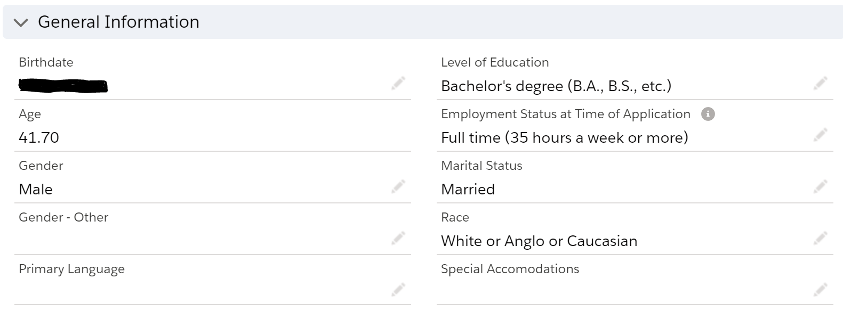

The second form of the user interface for this data is SAS Analytic tools which include SAS Enterprise Guide, and SAS Visual Analytics. The SAS tools are set up to connect to SQL server and recognize the database tables via SAS Libraries. Currently, our administrator has set up the connect for this database to SAS.

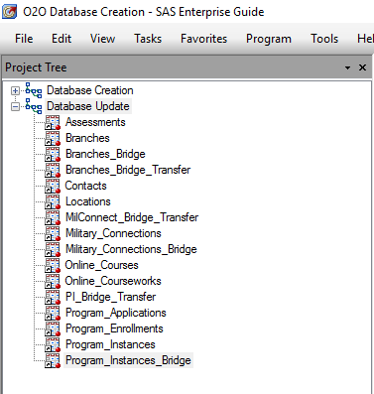

## Database Updates

All database updates will be completed the same way that the data was inserted into the new database from the current database, via SAS as an intermediary. Updates will be automatically schedule in SAS Enterprise Guide and all tables will include a query similar to the query below:

**proc** **sql**;

insert into DBO2OTST.Locations

select *

from (

select

ID as Location_ID

,Namex as Location_Name

,statex as Location_State

,lastmodifieddate as Location_Last_Modified_Date

from DBSFPRD.sf_location l

where not exists (select Location_ID from DBO2OTST.Locations d where l.ID = d.Location_ID))

; **quit**;

The query above is an update for the Locations table. This query inserts data into the Locations database table from a sub-query that only includes data that does not currently exist in the database. It will be done via a sub-query to avoid having to create an additional table as a transfer table as was done when the data was first inserted into the tables.

## Sample Reporting

Example View

go

Create view v_O2O_Outcome_Table as

select

c.Contact_ID

,Contact_Created_Date

,Contact_Employment_status

,Contact_Employer

,Contact_Position

,Contact_Employer_Instituion

,Contact_Employer_Partner

,Contact_Emp_Start_Date

,Contact_Employment_Location

,Contact_IVMF_Start_Date

,Contact_Employment_Zip

,Contact_Employment_Notes

,Contact_Outcome_Type

,Contact_Employment_Position

,Contact_IVMF_Salary_Range

,Contact_Type_of_Degree

,Contact_Confirmed_Hire_Date

,Contact_Hired_Location

,Contact_Salary_Range

,Contact_Hired_Zip

,Contact_Emp_Outcome_Type

,Contact_HHUSA_Opt_Out

,Contact_Sent_to_HHUSA

,pe.Program_Enrollment_ID

,pe.PE_Created_Date

,pe.PE_Advisor

,pe.PE_Status

,pe.Program_Instance_ID

,pa.Program_Application_ID

,pa.PA_Status

,pa.PA_Program_Application_Origin

,pa.PA_Program_Completion_Goal

,pa.PA_Live_Within_50m

,pa.PA_Orientation_Status

,i.PI_O2O_Model

,i.pi_program

,i.PI_Program_Instance_desc

,i.PI_Start_date

from Contacts as c

right join Program_Enrollments pe on c.Contact_ID = pe.Contact_ID

left join Program_Applications pa on pa.Program_Application_ID = pe.Program_Application_ID

left join Program_Instances i on pe.Program_Instance_ID = i.Program_Instance_ID

where SUBSTRING(c.Contact_Source, 1, 3) = 'O2O' or SUBSTRING(c.Contact_Source, 1, 4) = 'VCTP'

go

Example Function:

go

create function dbo.f_Age_at_Enroll (@Contact_ID char(18))

returns int as

begin

declare @returnValue int

select @returnValue = Datediff(year, C.Contact_Birthdate, pe.PE_Created_Date)

from Contacts c

right join Program_Enrollments pe on c.Contact_ID = pe.Contact_ID

where @Contact_ID = c.Contact_ID

return @returnValue

end

go

select dbo.f_Age_at_Enroll (c.Contact_ID) as AgeatEnroll

from Contacts c

Example Gender Query:

**proc** **sql**;

select

sum(case when Contact__Gender = 'Male' then **1** else **0** end)/count(Contact__Contact_ID) as Male format=percent8.2

,sum(case when Contact__Gender = 'Female' then **1** else **0** end)/count(Contact__Contact_ID) as Female format=percent8.2

,sum(case when Contact__Gender = 'Other' then **1** else **0** end)/count(Contact__Contact_ID) as Other format=percent8.2

,sum(case when Contact__Gender = '' then **1** else **0** end)/count(Contact__Contact_ID) as Missing format=percent8.2

from o2odsprd.cohorts

;**quit**;

Results:



Example Program Enrollment Status Report

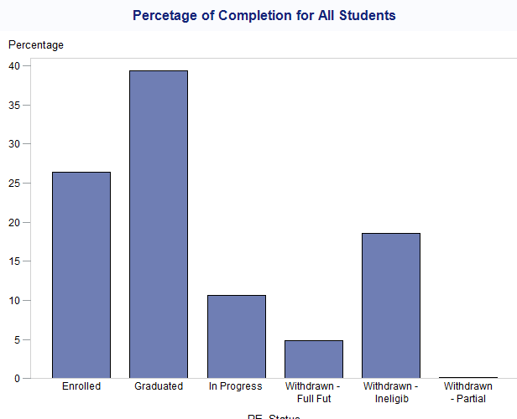

## Reflection

The largest assumptions I made during this project was that I would be able to get much more than done I was able to get done. The overall scope of the project was too large for this class. Part of that was on purpose in that I wanted to get done a large portion of the database needed for my organization, but part of that was accidental in that I did not realize I would need additional tables until I started coding the database. Additionally, there are still data integrity issues in the operational database (Salesforce) that causes issues with the foreign keys constraints that I did not anticipate (which is why the insert statements for the tables align with the data that already exists in the other tables). For example, there were contact ID in the Program Enrollments table that did not exist in the Contacts table, which should not be possible if the operational database was set up correctly. In this case, it was not set up correctly and is in the process of being fixed. This has many downstream effects on my database.

This project was a draft of the database we are going to create for my organization. Moving forward, I will need to go back to the consumers of the data and double check we have the correct fields and some of the fields need to be edited. For example, the Program Enrollments Status field was too short. In addition to these, other fields need to be added that I did not know that I needed in the beginning to multiple tables. The new column need for multiple tables is an ID field, for which I would need to create an additional table to connect to. Additionally, I used SAS as an intermediary for this project, which for the data that does not need to be cleaned was unnecessary. When created the final product, I am going to pull directly from the other database in SQL Management Studio, reducing the number of steps needed for the final product and updates.

Overall, the experience of creating my own database was incredibly eye opening to how difficult it is to pull off. The overall coding is not that difficult but ensuring everything will work seamlessly together is quite difficult to get right. How data will interact with the constraints is something I learned very deeply after failing to insert data many, many times and not being able to figure out why. The coding of the database was much easier with a good planning phase, and I now know more than ever how important a detailed planning phase is in this type of project.

## Final Summary

For my project, certain details such as the user interface and source for the data were already determined by the business need. The final user interface for data input is Salesforce, and the user interface for data analysis is SAS Enterprise Guide and SAS Visual Analytics. All these UI’s are currently connected and did not need additional support on my end to utilize them. The overall project stayed relatively the same, however I did make edits to part I of this project by editing the field lengths, adding fields that I did not originally include and delete a table that was not needed (Program Instance Bridge table). To answer the data questions, I created a reporting view which is basically a copy of the current Salesforce report we currently utilize to report. This view contains many more joins but allows much more control as to how the data is joined. While Salesforce is good for many things, it is difficult to determine how Salesforce joins many tables behind the scenes. Working from a database allows for much more control of the data. The data can now be used in our static reports from code, or dynamic reports in Visual Analytics to allow consumers of the data to utilize it. This project is now ready to be revised, edited, and then will be ready to be implemented as the source of our data needs. This eliminates the manual process of downloading excel reports from Salesforce and uploading them into SAS. Additional work will be needed to optimize the process; however, this is a large step in the right direction.